IN THE NAME OF THE MOST MERCIFUL

Language Policy

Revised March 2022

IB Mission Statement:
The International Baccalaureate® aims to develop inquiring, knowledgeable and caring young people who help to create a better and more peaceful world through intercultural understanding and respect. To this end the organization works with schools, governments and international organizations to develop challenging programs of international education and rigorous assessment. These programs encourage students across the world to become active, compassionate and lifelong learners who understand that other people, with their differences, can also be right.
Guide Academy Mission and Vision
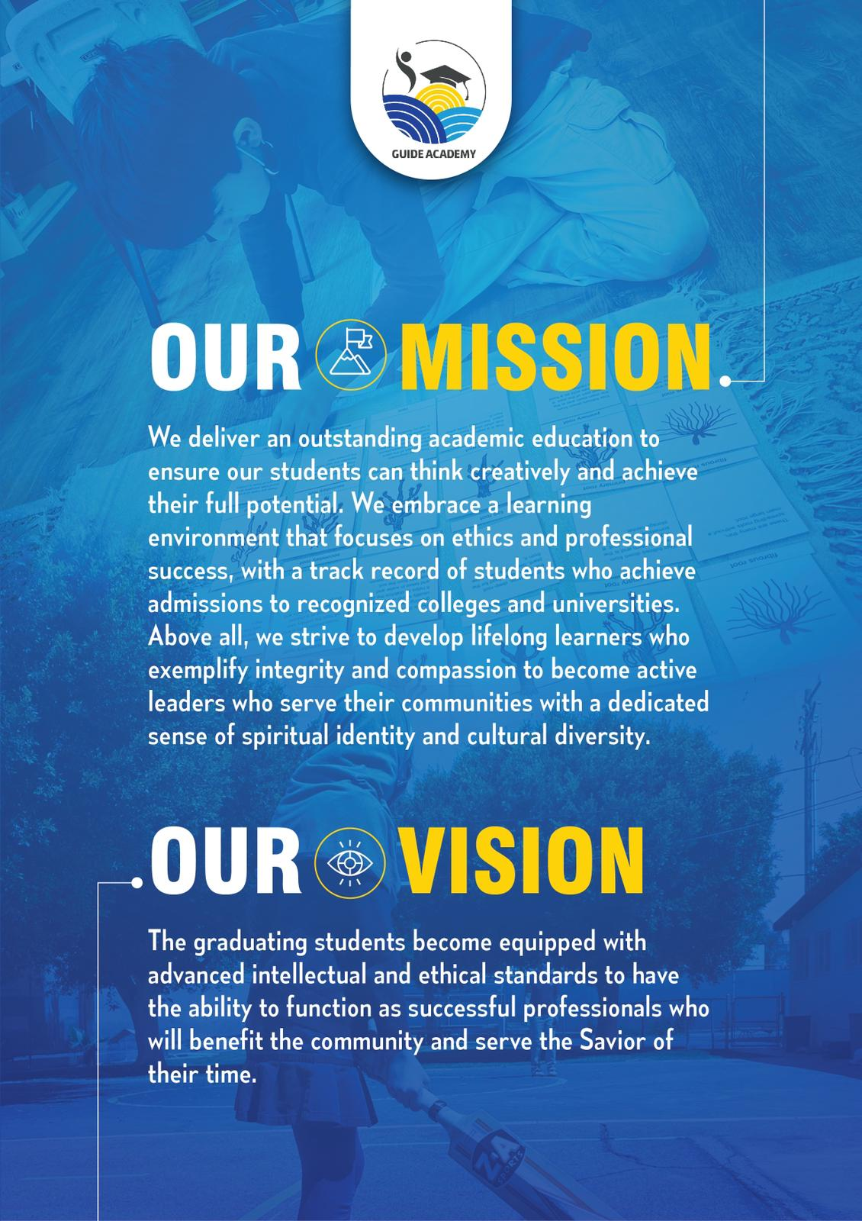

What is International Baccalaureate MYP?

As IB explains, the International Baccalaureate Middle Years Program (IB MYP) is designed for students ages 11 to 16 (grades 7-10 in our school). It provides a framework of learning that encourages students to become creative, critical, and reflective thinkers. The MYP emphasizes rigorous assessment and intellectual challenge, encouraging students to make connections between their studies in their subjects and the real world. It fosters the development of skills for communication, intercultural understanding, and global engagement; qualities that are essential for life in the 21st century. Importantly, the MYP is flexible enough to accommodate the demands of most national and local curriculums.

What does MYP mean for students?
The IB MYP creates a student-focused curricular framework that works towards the following:
● Addresses students' intellectual, social, emotional, and physical well-being holistically
● Provides students opportunities to develop the knowledge, attitudes, and skills they need in order to manage complexity and take responsible action for the future
● Ensures breadth and depth of understanding through study in eight subject groups
● Requires the study of an additional language
● Empowers students to participate in service within the community
● Helps to prepare students for further education, and/or the workplace

The school’s language policy is intended to help the school to engage meaningfully with IB language expectations and develop these in the context of the school’s unique circumstances.

What will the MYP look like at Guide Academy?
Each year, teachers work to create and implement new, as well as existing units, that have all the components of the IB MYP. Students are assessed according to the predetermined IB criteria, and both teachers and students reflect on that unit in order to revise or refine it for the future. Students will begin using some of the IB terminology from the Learner Profile (below) when describing characteristics about themselves and others, and reflecting on how to improve themselves towards those attributes. Guide academy has developed language policies aligned with the goal of developing all the learner profile attributes (Learner profile for IB students - International Baccalaureate® (ibo.org)), specially strong communicators who are also open-minded.

Language Policies
This statement provides a common understanding of the language policies of the school where its governing board and all the stakeholders agree upon. The Montadhar PEACE Educational school (Guide Academy dba) was established by a group of dedicated individuals who felt a desperate need of professionals in the world, who can make positive effects not only in the academic fields but also in the ethical world. To direct our children to reach their potential, founders and teachers foster the languages that satisfy the host country plus the mother language including the Highest Standards of the state of California combined with Ethical values & Self-Management.
Language is a vital tool for understanding challenges, and changes in the community which the students serve, which leads to their success.
Guide Academy has a community-centric philosophy, and the language policies of the school will consider the education of the community of students, teachers, parents, volunteers, and Alumni. Therefore, multilingualism and progress in advanced literacy is essential to the development of cultural identity, international-mindedness, and universal respect and awareness.
At Guide Academy all teachers are language teachers (standard C1), as all curriculum is transcended through language, and ALL teachers collaborate, plan and are responsible for language development of the students (standard C3); through the IB language policies we want to train students who:
- focus on personal development rather than exams
- produce more mature, creative and socially adept children who are multilingual
- ESL students are encouraged to speak the English language until fluent
- Fluent English speaking students are allowed to speak mother language in the school
- Speak Arabic (as a second language) fluently while in the IB program
- write "significantly more creative" essays using more sophisticated sentence structures,
- develop and implement a written curriculum consistent with the IB program (standard C2)
- display a greater sense of "justice and fairness", and be less likely to engage rough activities, develop and implement policies consistent and supportive to the IB program (standard B1)
- Assessments align with all the requirements of the IB program (standard C4)
- individual liberty of students to choose their own interests (in the written & spoken language) following their inner guidance for self-directed learning
- develop sensitivity for imagination and social interaction with others through preferred language (after fluency in English, Arabic or mother language).
- become confident, curious, highly proficient and enthusiastic readers, writers, viewers, presenters, speakers and listeners. Language is always taught meaningfully and in context.
- Demonstrate leadership using respectful language for ALL cultures, religions, beliefs, etc (standard B1)
- The school utilizes the resources and expertise of the community to enhance learning within the programs (IB Standard B2, Practice 11).

At Guide Academy, language is taught through inquiry, letting students to make relations with context, to discover and research. As a Montessori and IB (MYP) school in Anaheim, California, nurturing Muslim students, the main curriculum is taught in English, and Arabic as a second language, however, we are devoted to delivering students with access to the mother tongue learning languages like Farsi, Spanish, French, and Urdu which will satisfy their cultural experiences throughout the curriculum. Equally important to the school is the belief that each student should have the opportunity to maintain and develop their mother tongue(s) (IB Standard A). The acquisition of additional languages allows students to further reflect upon and explore different cultural perspectives.
Guide Academy provides support for English as a Second Language (ESL) students by providing tools and teachers with mother language until students become proficient in English language, however, speaking in the English & Arabic languages are encouraged during the school hours. At Guide Academy, students are encouraged to give presentations on special events like “Fathers Day”, “Mother’s Day” etc, in different languages, especially English, Arabic and any other languages which they are studying. The library has books with other languages (mother languages) and the students are encouraged to borrow those books and once read to share with others.

For Guide Academy, multilingualism and the development of critical literacy are considered important factors in nurturing international-mindedness through the advancement of cultural uniqueness and understanding practicing global citizenship. The vision of Guide Academy is to train pious individuals who will benefit their community and serve the Savior of their time at the Global Level, and that is the aim and goal of the language policy.
This policy is a dynamic document, will be revised and re-revised by the different members of the community (teachers, admin, board members, etc) to fit the culture of the school helping towards the mission & vision of both school and IB program.

