IN THE NAME OF THE MOST MERCIFUL
GUIDE ACADEMY

Inclusion Policy

Revised March 2022

IB Mission Statement:
The International Baccalaureate® aims to develop inquiring, knowledgeable and caring young people who help to create a better and more peaceful world through intercultural understanding and respect. To this end the organization works with schools, governments and international organizations to develop challenging programs of international education and rigorous assessment. These programs encourage students across the world to become active, compassionate and lifelong learners who understand that other people, with their differences, can also be right.
Guide Academy Mission and Vision
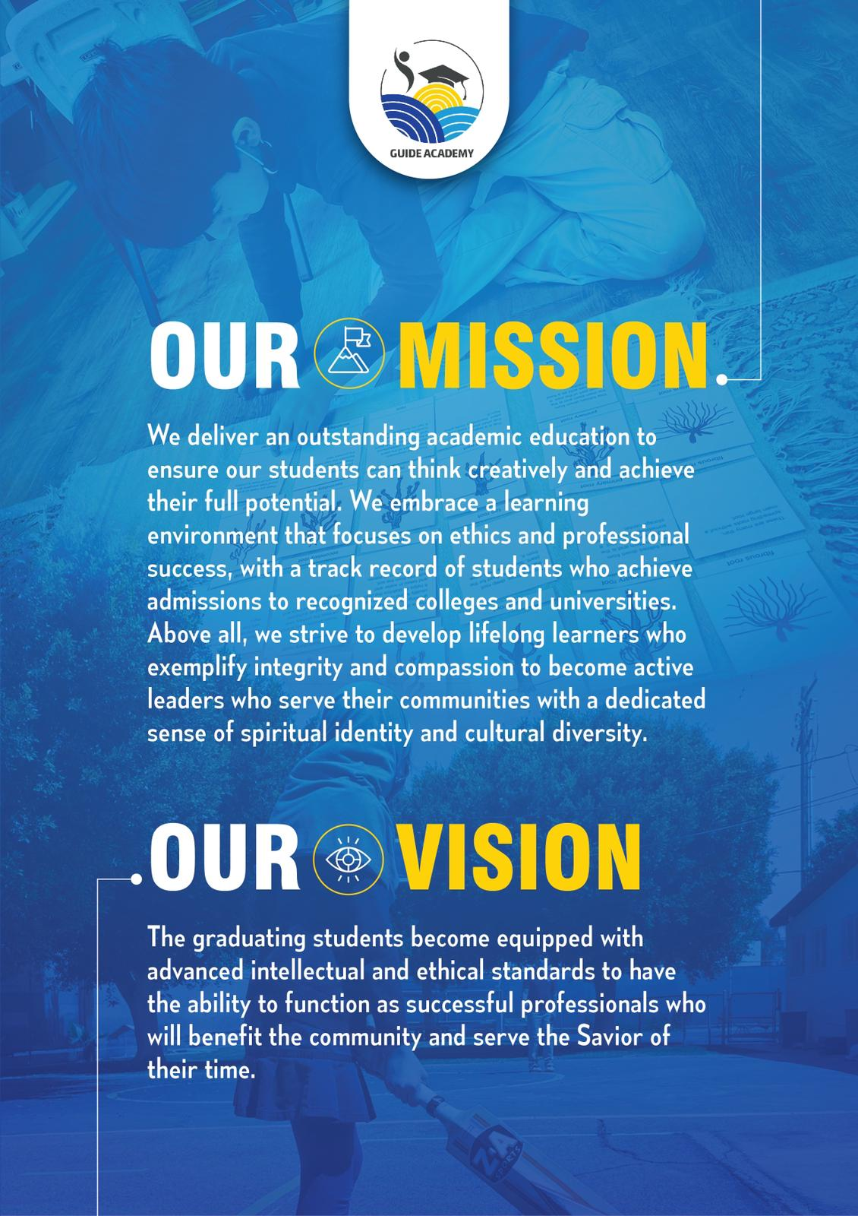

What is International Baccalaureate MYP?

As IB explains, the International Baccalaureate Middle Years Program (IB MYP) is designed for students ages 11 to 16 (grades 7-10 in our school). It provides a framework of learning that encourages students to become creative, critical, and reflective thinkers. The MYP emphasizes rigorous assessment and intellectual challenge, encouraging students to make connections between their studies in their subjects and the real world. It fosters the development of skills for communication, intercultural understanding, and global engagement; qualities that are essential for life in the 21st century. Importantly, the MYP is flexible enough to accommodate the demands of most national and local curriculums.

What does MYP mean for students?
The IB MYP creates a student-focused curricular framework that works towards the following:
● Addresses students' intellectual, social, emotional, and physical well-being holistically
● Provides students opportunities to develop the knowledge, attitudes, and skills they need in order to manage complexity and take responsible action for the future
● Ensures breadth and depth of understanding through study in eight subject groups
● Requires the study of an additional language
● Empowers students to participate in service within the community
● Helps to prepare students for further education, and/or the workplace

The school’s inclusion policy is intended to help the school to engage meaningfully with IB inclusion expectations and develop these in the context of the school’s unique circumstances.

What will the MYP look like at Guide Academy?
Each year, teachers work to create and implement new, as well as existing units, that have all the components of the IB MYP. Students are assessed according to the predetermined IB criteria, and both teachers and students reflect on that unit in order to revise or refine it for the future. Students will begin using some of the IB terminology from the Learner Profile (below) when describing characteristics about themselves and others, and reflecting on how to improve themselves towards those attributes. Guide academy has developed inclusion policies aligned with the goal of developing students who embody all the learner profile attributes (Learner profile for IB students - International Baccalaureate® (ibo.org)), specially balanced risk takers who are constantly reflecting on improving their abilities to reach their full potential.
Philosophy
Guide academy consistently strives to employ available resources to provide the best education possible for every child. Our ultimate aim is to benefit the whole school community, while ensuring that all students are thriving in an inclusive environment where the needs and learning styles of every individual student is understood and met.
Guide academy does not discriminate against any child in the admission process based on race, religion, nationality, gender, disability or special educational needs. We will accept any student interested in gaining a high quality education as long as we have, or are able to acquire, the resources required to support the student. The Guide Academy campus building is also physically accessible via a side gate with ramp.
The Montessori curriculum, which is employed by Guide Academy for students from pre-k to grade 6, was originally designed for students with special educational needs, and is therefore highly compatible with ensuring inclusion of all students. The IB framework, which is the only program offered from grades 7 to grade 10, is also highly compatible and encouraging of an inclusive education for all.
Guide academy is currently supporting students with autism, ADHD and ADD. All teachers are encouraged to complete the AFIRM Modules | AFIRM (unc.edu) designed to provide resources and strategies to support students with Autism. The leadership has attended the workshop “Understanding stress and anxiety within dyslexic children and building resilience” offered by the British dyslexia association.
We are continuously ensuring our teachers receive the information, support, and training necessary to be able to support our students and as the need arises, new training offered by the IB and other institutions are sought and completed.
Definition of Inclusive Education
Guide academy embraces the definition of inclusion defined in the IB document “learning diversity and inclusion in IB programs”.
“Inclusion is an ongoing process that aims to increase access and engagement in learning for all students by identifying and removing barriers. Inclusion is an organizational paradigm that involves change. It is a continual process of increasing learning and participation for all students. It addresses learning support requirements and questions the broader objectives of education, the nature of pedagogy, curriculum and assessment. It is an educational approach to which all schools should aspire. Inclusion is facilitated in a culture of collaboration, mutual respect, support and problem-solving involving the whole school community.” (IBO, 2)
Barriers to inclusive education
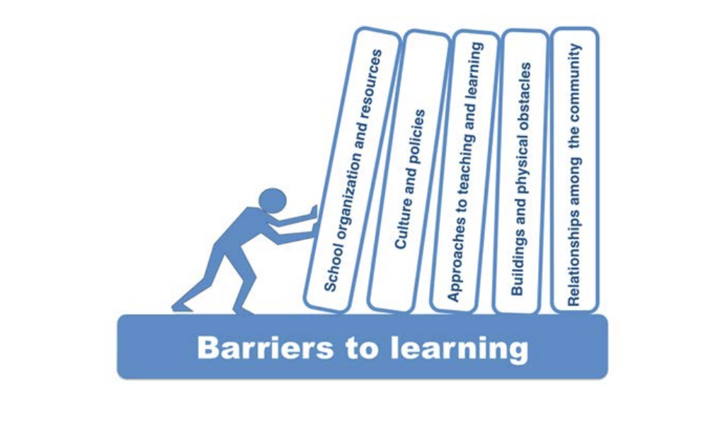
Figure 1. Removing Barriers to learning (IBO, 4)
Guide academy strives to consistently remove all barriers to effective learning for all students. The figure above shows the possible areas where barriers to learning may exist. “It is the responsibility of the senior leadership team and school board in consultation with educators, learning support professionals, parents, students and all stakeholders to put in place processes to remove barriers to learning for every member of the school community. It is the responsibility of every teacher, as a teacher of all students, to make sure that each student is exposed to teaching and learning that reaches them as individual learners.” (IBO,7 )
The allocation of resources to support an inclusive education is a team responsibility involving the head of school, academic director, coordinator and teachers for reporting to the school counselor who will find, allocate and deploy resources.
Evaluation and Procedures
Guide Academy’s procedure for the identification and evaluation of students with learning needs are as below:
- Physical or mental health needs and concerns are requested in admission forms.
- Teachers identify students who need support and report to school administration.
- BASC testing forms are utilized and filled in by teachers and parents and/or students.
- Needed resources and support strategies and information is identified by leadership team and counselor and provided to teachers.
- Teachers are trained in specialty areas as the need arises.
- If needed, the school counselor is involved to support the student via one to one meetings or in - class support.
- Arrangements are made for access for assessments and learning experiences
- Progress of students is monitored closely by school administration and the school ensures ongoing communication with parents and/or legal representatives of the student.
- The Orange County Department of Education is consulted for further support and guidance if needed.
Confidentiality
All information communicated and coordinated during transition stages of students—changing schools or changing sections within the school is treated with strict confidentiality. Guide Academy ensures it always abides by data protection and privacy legislations, including those with respect to student privacy and health information privacy.
Induction of teachers
All new teachers will have one to one meetings with the coordinator and head of school during the induction process where all school policies are thoroughly explained and discussed. IB Professional development training will follow and the teacher will be provided with support of the coordinator and teachers to gain background information to be able to join in school training sessions and regular weekly collaborative planning meetings.
School Policies and Review Process
The inclusion policy is closely linked to the schools language and assessment policies. Guide Academy’s leadership team consistently promotes inclusive practices in teaching, learning and assessment, including language learning. Parents are offered education sessions and workshops covering various topics around inclusion. Teachers are encouraged to include differentiation and inclusion strategies in all unit planners, and plan for access of all students to higher achievement levels when assessing. Academic integrity is always taken very seriously, including in cases where students need more support.
All school policies will be made available on the school website and sent out by emails regularly to invite the school community’s feedback. Social media pages encourage the community to review and provide feedback on the policies.
School policies are reviewed as the need arises or on a bi-annual basis by the school leadership team.
Works Cited
International Baccalaureate Organization.Learning Diversity and Inclusion in IB Programs. Cardiff, UK, International Baccalaureate Organization, Jan. 2016,. Accessed 23 Nov. 2021.

