IN THE NAME OF THE MOST MERCIFUL

Assessment Policy

Revised March 2022

IB Mission Statement:
The International Baccalaureate® aims to develop inquiring, knowledgeable and caring young people who help to create a better and more peaceful world through intercultural understanding and respect. To this end the organization works with schools, governments and international organizations to develop challenging programs of international education and rigorous assessment. These programs encourage students across the world to become active, compassionate and lifelong learners who understand that other people, with their differences, can also be right.
Guide Academy Mission and Vision
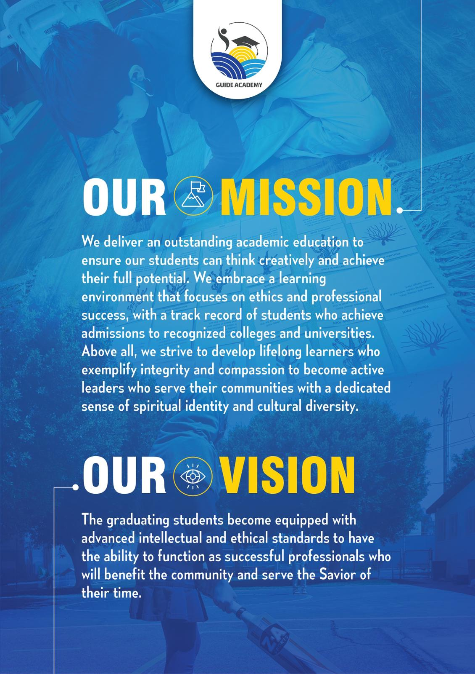

What is International Baccalaureate MYP?

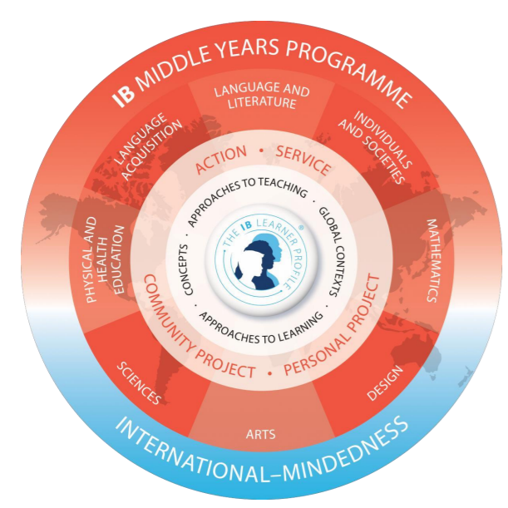
As IB explains, the International Baccalaureate Middle Years Program (IB MYP) is designed for students ages 11 to 16 (grades 7-10 in our school). It provides a framework of learning that encourages students to become creative, critical, and reflective thinkers. The MYP emphasizes rigorous assessment and intellectual challenge, encouraging students to make connections between their studies in their subjects and the real world. It fosters the development of skills for communication, intercultural understanding, and global engagement; qualities that are essential for life in the 21st century. Importantly, the MYP is flexible enough to accommodate the demands of most national and local curriculums.

What does MYP mean for students?
The IB MYP creates a student-focused curricular framework that works towards the following:
● Addresses students' intellectual, social, emotional, and physical well-being holistically
● Provides students opportunities to develop the knowledge, attitudes, and skills they need in order to manage complexity and take responsible action for the future
● Ensures breadth and depth of understanding through study in eight subject groups
● Requires the study of an additional language
● Empowers students to participate in service within the community
● Helps to prepare students for further education, and/or the workplace
The school’s assessment policy is intended to help the school to engage meaningfully with IB assessment expectations and develop these in the context of the school’s unique circumstances.

What will the MYP look like at Guide Academy?
Each year, teachers work to create and implement new, as well as existing units, that have all the components of the IB MYP. Students are assessed according to the predetermined IB criteria, and both teachers and students reflect on that unit in order to revise or refine it for the future. Students will begin using some of the IB terminology from the Learner Profile (below) when describing characteristics about themselves and others, and reflecting on how to improve themselves towards those attributes. Guide academy has developed assessment policies aligned with the goal of developing all the learner profile attributes, specially knowledgeable, reflective inquirers a culture of continuous growth and learning.
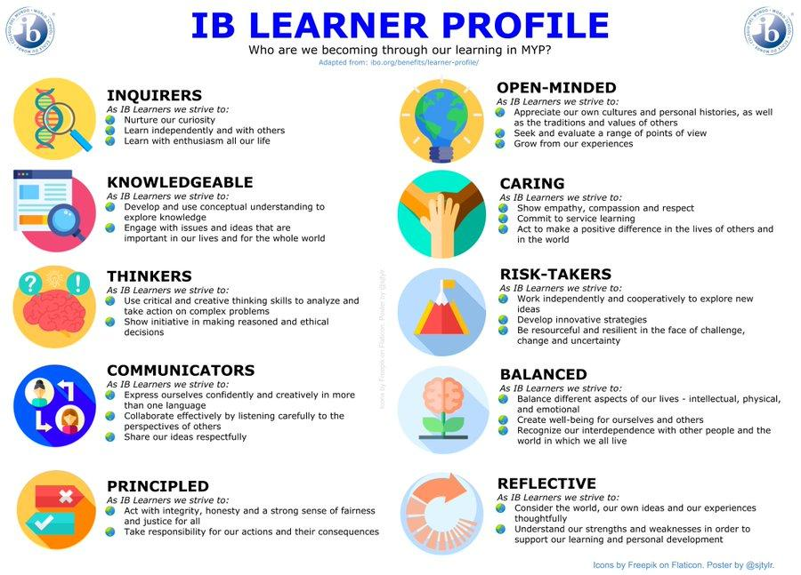

IB MYP ASSESSMENT
Philosophy and purpose of assessment
Teachers support students by encouraging learning. They do this by providing feedback on their learning process. Teachers will provide an opportunity for the students to show their transfer of skill across the disciplines.
Assessment is integral to all teaching and learning. MYP assessment requires teachers to assess the prescribed subject-group objectives using the assessment criteria for each subject group in each year of the programme. In order to provide students with opportunities to achieve at the highest level, MYP teachers develop rigorous tasks that embrace a variety of assessment strategies. In the MYP, teachers make decisions about student achievement using their professional judgment, guided by mandated criteria that are public, known in advance and precise, ensuring that assessment is transparent. Across a variety of assessment tasks (authentic performances of understanding), teachers use descriptors to identify students’ achievement levels against established assessment criteria. MYP internal (school-based) assessment uses a “best-fit” approach in which teachers work together to establish common standards against which they evaluate each student’s achievement holistically. This “criterion-related” approach represents a philosophy of assessment that is neither “norm-referenced” (where students must be compared to each other and to an expected distribution of achievement) nor “criterion-referenced” (where students must master all strands of specific criteria at lower achievement levels before they can be considered to have achieved the next level).
Assessment in the MYP aims to:
• support and encourage student learning by providing feedback on the learning process
• inform, enhance and improve the teaching process
• provide opportunity for students to exhibit transfer of skills across disciplines, such as in the personal project and interdisciplinary unit assessments
• promote positive student attitudes towards learning
• promote a deep understanding of subject content by supporting students in their inquiries set in realworld contexts
• promote the development of critical- and creative-thinking skills
• reflect the international-mindedness of the programme by allowing assessments to be set in a variety of cultural and linguistic contexts
• support the holistic nature of the programme by including in its model principles that take account of the development of the whole student.
Assessment practices in the MYP can sometimes represent significant challenges to existing school practices. Some key features of MYP assessment include:
• distinction between internal summative assessment and the supporting formative processes • attention to the most accurate demonstration of student performance, rather than mechanically and uncritically averaging achievement levels over given reporting periods
• assessment of student understanding at the end of a course, based on the whole course and not individual components of it.
Students must be able to recall, adapt and apply knowledge and skills to new questions and contexts. Students need to understand assessment expectations, standards and practices, which teachers can introduce early and naturally in teaching, as well as in class and homework activities.
The MYP places an emphasis on assessment processes that involve the gathering and analysis of information about student performance and that provide timely feedback to students on their performance. MYP assessment plays a significant role in the development of ATL skills, especially skills that are closely related to subject-group objectives. The MYP approach to assessment recognizes the importance of assessing not only the products, but also the process, of learning.
MYP internal assessment includes tasks, strategies and tools that are designed, developed and applied by teachers working with students in their schools. Teachers are well placed to assess the work of their MYP students; this assessment model supports the professional judgment of teachers in deciding the achievement levels of individual students. MYP assessment encourages teachers to monitor students’ developing understanding and abilities throughout the programme. Through effective formative assessment, teachers gather, analyse, interpret and use a variety of evidence to improve student learning and to help students to achieve their potential. Student peer and self-assessment can be important elements of formative assessment plans. Internal (school-based) summative assessment is part of every MYP unit. Summative assessments are designed to provide evidence for evaluating student achievement using required MYP subject-groupspecific assessment criteria. Internal summative and formative assessments are closely linked, and teachers must use their knowledge of IB assessment expectations and practices to help students improve performance through consistent, timely and meaningful feedback. By assessing students as they develop disciplinary and interdisciplinary understanding, teachers identify student learning needs in order to better inform the learning process. Assessment in the MYP is not confined to the final part of a learning period, such as the end of a unit. Formative assessments can be planned from the start of a unit, although they may change as teachers engage with students to determine the next stages of learning.
In summary, when creating MYP units, teachers must ensure that assessments:
• are integral to the learning process
• are aligned with subject-group objectives
• gather information from a variety of perspectives, using a range of tasks according to the needs of the subject and the nature of the knowledge, skills and understanding being assessed • are appropriate to the age group and reflect the development of the students within the subject
• provide evidence of student understanding through authentic performance (not simply the recall of factual knowledge).
What are the assessment components of the MYP program?
Assessment in the MYP is best described as internal because the assessment tasks, strategies, and tools are designed, developed, and applied by teachers working with students in their schools. The IB believes that teachers are best placed to assess the work of their MYP students; the assessment model supports the professional judgment of the teacher in deciding the levels of achievement of individual students. The MYP identifies a set of objectives for each subject group, which are directly related to the assessment criteria of that particular subject group.
Teachers are responsible for structuring varied and valid assessment tasks that will allow students to demonstrate achievement according to the required objectives within each subject group. These include, but are not limited to, open-ended, problem-solving activities and investigations, organized debates, tests and examinations, hands-on experimentation, analysis, and reflection.
Assessment is conducted via both formative and summative forms. Formative assessment represents the process of gathering, analysing, interpreting and using the evidence to improve student learning and to help students to achieve their potential. It is one essential component of classroom practice and needs to be integrated into the curriculum. Summative assessment is concerned with measuring student performance against the MYP assessment criteria to judge levels of attainment. Summative and formative assessments are, therefore, inherently linked and teachers must use their knowledge of IB summative assessment expectations and practices to help students improve performance in a formative way.

Aims, objectives, criteria and strands in MYP assessment?
Teaching and learning in the Middle Years Programme (MYP) is organized by
• aims (general statements about what teachers may expect to teach or do, what students may expect to experience or learn, and how students may be changed by the learning experience)
• objectives (statements which describe the skills, knowledge and understanding that will be addressed in the subject group).
The subject group’s assessment criteria align with the objectives. Teachers use assessment criteria to judge the extent to which students have been successful in achieving the objectives for the unit or the course. Strands are aspects or elements of subject-group objectives or criteria; or put another way, strands are a detailed breakdown of what each objective or criterion encompasses or entails.
Assessment Strategies and Tasks used in the MYP:
- Observation of student (particularly useful for assessing some attitudes and skills)
- Selected responses (tests and quizzes)
- Open-ended tasks (essays, diagrams, presentations, organized debates, problem-solving activities, investigations and research)
- Performances
- Hands-on experimentation
- Process journals (reflection)
- Portfolio assessment
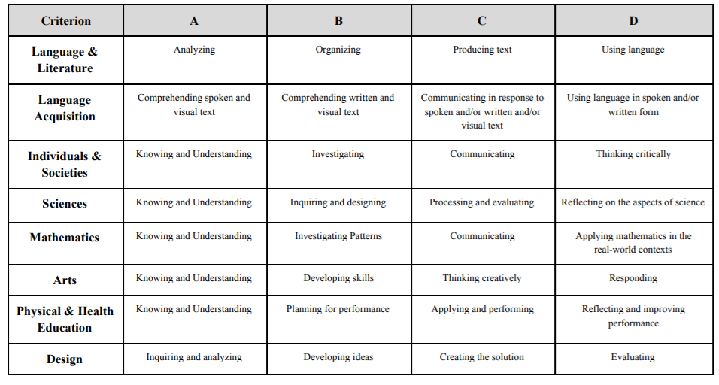
The most important aim of the MYP assessment is to support and to encourage student learning, recognizing the importance of assessing the processes as well as the products of learning. To this end, students know the criteria at the beginning of the unit and have an understanding of what it will take to achieve the criteria level they aspire to. They also receive feedback from teachers letting them know where they are on the criterion rubric scale. These assessment criteria will be shared in the beginning of the unit, and the scores will be shared at the unit’s conclusion. You will receive a grade from 0-8 for each summative task. The following is an example of the descriptors for a science class –
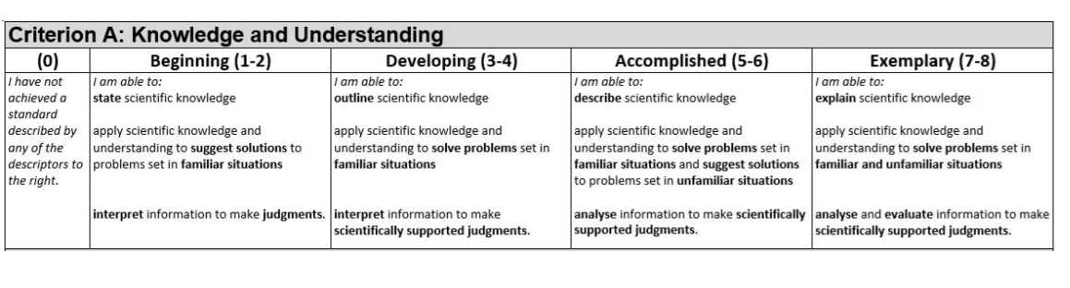
Students’ grades from each criterion will then be added to a final grade out of 32. This grade is then converted to a grade out of 7 for your report card as shown below.
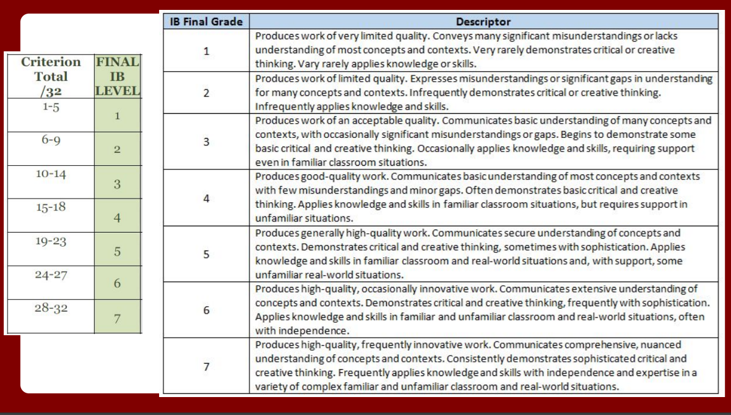
When will I know that students are experiencing MYP components?
Classroom teachers will post their unit planners on Managebac and instruct students on the components of the IB unit. Students and parents are encouraged to be active on Managebac on a daily basis. All learning is organized into the structure of IB units and the philosophy of IB is interwoven into all aspects of teaching and learning. IB MYP requires that classrooms are student-centered. Teachers follow best practices that engage students in carefully sequenced inquiry-based learning experiences. These experiences are framed in units that cause students to think and answer inquiry questions that help students make global connections and build toward the assessments. Action-based lessons, group collaboration, and developing habits of mind integrate the social-emotional component of learning. IB MYP also embraces and utilizes best practices of differentiated instruction, helping challenge and support all students – from those who are struggling to those who are advanced. This student-centered learning allows for a wide range of involvement for the student, which in turn encourages students to become lifelong learners, connected to their world and others, who inhabit the world with them.
Best fit Judgment in MYP Assessment
The best-fit approach reflects the criterion-related philosophy of MYP assessment. In distinction from criterion-based assessment, the MYP approach does not require students to meet every strand of a criterion in order to be awarded a specific achievement level or progress to the next level. MYP assessment relies on teachers’ professional judgment to develop and apply shared understandings of “what good looks like”.
Criterion-related assessment (marking) works like this:
1. Locate the appropriate assessment criteria (year 1, 3 or 5) in the guide.
2. Choose one strand of the criterion being assessed; starting with level 0, move through each band until you reach a statement that no longer describes the student’s level of achievement.
3. Note the next lowest achievement level and confirm that it accurately describes the student’s work.
4. Repeat this process for each strand of the criterion being assessed.
5. Observe the pattern of achievement across levels against the relevant strands.
6. If most or all descriptors of the student’s work lie within the same achievement level, make a holistic judgment about whether the student’s work demonstrates the qualities described in that band to a greater extent (awarding the higher level) or a lesser extent (awarding the lower level).
7. If the descriptors are distributed across multiple achievement levels, use your professional judgment to select the level (0 or 1–8) that, overall, best matches the student’s work. Remember, students do not have to demonstrate that every relevant strand of the criterion describes their work in order to be awarded an achievement level in that band.
8. Record only whole numbers (do not use fractions or decimals in making best-fit judgments).
Additional considerations for good practice in best-fit assessment:
• Teachers should not define a pass or fail boundary, but rather should concentrate on identifying the most appropriate descriptors for each assessment criterion.
• The highest level descriptors do not imply faultless performance and they represent an achievable challenge. Teachers should use the entire range of available levels as appropriate.
• Student achievement often varies across criteria. Students who attain a high achievement level for one criterion (or strand) will not necessarily attain high achievement levels for other criteria (or strands). Similarly, students who attain a low achievement level for one criterion (or strand) will not necessarily attain low achievement levels for other criteria (or strands).
• Teachers should not assume that criterion-related assessment will produce a standard distribution of achievement levels or MYP grades.
• Teachers should make assessment criteria and task-specific clarifications available to students in advance. Classroom discussion and individual conferences can often focus profitably on assessment criteria, strands, descriptors, achievement levels, criteria level totals and MYP grades.
Using criterion in a summative assessment task
Using one criterion for a summative assessment task is allowed. In some subject groups, specific criteria are appropriate for certain kinds of assessment tasks. In others, focusing on one criterion can help students by scaffolding (or “chunking”) complex performances of understanding.
Working collaboratively, teachers should design holistic interdisciplinary summative assessment tasks (performances of understanding), which assess multiple criteria whenever possible.
Every strand of the criterion does not have to be used when developing a formative or summative assessment tasks. In earlier years of the programme, students can often profit from focusing on particular strands of a criterion. In many cases, however, good practice in MYP assessment uses as many strands of the criterion as appropriate when developing summative assessment tasks.
Consequences for late assessment
At guide academy, in alignment with the criterion related assessment philosophy of the MYP, does not encourage decreasing marks for late assessment. Instead, teachers are free to choose from the following procedures:

- More than two late formative assessments per unit does not allow studentsto take the summative assessment. If formative assessment does not meet teacher/student satisfaction or expectations students are allowed to make-up assignment. Make-up formative assessments are to be turned in on the new given date, on time or it will be counted as late.

- Summative assessments can only be taken when all formatives are done. There will be consequences fo late formatives at the discretion of the teacher, for example, the summative will be harder for students with late formatives.

- Students are solely responsible for their own learning and should understand that not completing formative assessments will not allow them to receive meaningful feedback from their teachers and hence they will not be prepared for their summative assessments. In this approach, there is no penalty for late or missing formatives, other than the natural consequence of underperforming in the summative.

Policy Review
This policy will be reviewed by the leadership team and teachers on a bi-annual basis or as needed. The policy will be posted on the school website and all stake holders including board members, staff, parents and students are invited to share their input via regular emails from the school.

