IN THE NAME OF THE MOST MERCIFUL

Academic Honesty Policy

Revised March 2022

IB Mission Statement:
The International Baccalaureate® aims to develop inquiring, knowledgeable and caring young people who help to create a better and more peaceful world through intercultural understanding and respect. To this end the organization works with schools, governments and international organizations to develop challenging programs of international education and rigorous assessment. These programs encourage students across the world to become active, compassionate and lifelong learners who understand that other people, with their differences, can also be right.
Guide Academy Mission and Vision

What is International Baccalaureate MYP?

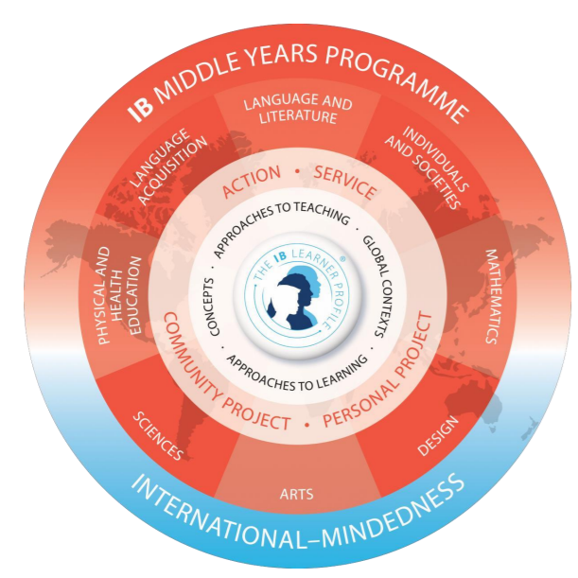
As IB explains, the International Baccalaureate Middle Years Program (IB MYP) is designed for students ages 11 to 16 (grades 7-10 in our school). It provides a framework of learning that encourages students to become creative, critical, and reflective thinkers. The MYP emphasizes rigorous assessment and intellectual challenge, encouraging students to make connections between their studies in their subjects and the real world. It fosters the development of skills for communication, intercultural understanding, and global engagement; qualities that are essential for life in the 21st century. Importantly, the MYP is flexible enough to accommodate the demands of most national and local curriculums.

What does MYP mean for students?
The IB MYP creates a student-focused curricular framework that works towards the following:
● Addresses students' intellectual, social, emotional, and physical well-being holistically
● Provides students opportunities to develop the knowledge, attitudes, and skills they need in order to manage complexity and take responsible action for the future
● Ensures breadth and depth of understanding through study in eight subject groups
● Requires the study of an additional language
● Empowers students to participate in service within the community
● Helps to prepare students for further education, and/or the workplace

What will the MYP look like at Guide Academy?
Each year, teachers work to create and implement new, as well as existing units, that have all the components of the IB MYP. Students are assessed according to the predetermined IB criteria, and both teachers and students reflect on that unit in order to revise or refine it for the future. Students will begin using some of the IB terminology from the Learner Profile (below) when describing characteristics about themselves and others, and reflecting on how to improve themselves towards those attributes. Guide academy has developed academic honesty policies aligned with the goal of developing all the learner profile attributes, specially caring and principled inquirers in a culture of integrity and fairness.
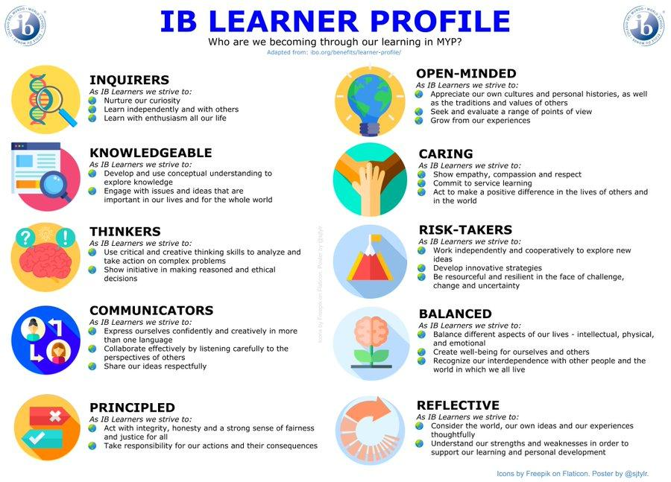

Academic Integrity Policies
Guide Academy has a mission to ensure success and professionalism of all the students and to preserve academic integrity. According to the IB, academic integrity is influenced and shaped by a variety of factors including peer pressure, culture, parental expectations, role modeling and taught skills (IBO Academic Honesty, 2009). At Guide Academy, academic honesty is seen as a set of values and skills that promote personal integrity and good practice in teaching, learning, and assessment. Competency is measured based on human values, and therefore highest levels of academic integrity is expected in all assignments and assessments including external Stanford Achievement Testing (SAT) and internal formative and summative assessments..
Our expectations are set out in this policy. All members of our school community need to be aware that the school treats academic honesty as an integral part of who we are.
Students must utilize the IB Learner Profile daily in the school. In particular, academically honest students are principled, open-minded, and caring. Teachers will ensure complete understanding for all grade levels of what is meant by cheating, plagiarism, and other examples of academic dishonesty.
An academically honest student:
Does
- His/Her own work with integrity and honesty
- Acknowledge the source of direct quotations
- Acknowledge information taken from books, databases, and the internet
- Acknowledge reference materials in a bibliography
- Know what constitutes cheating and abides by the academic code and conduct outlined in this policy
- Informs school officials of those around them who cheat
Does Not
- Use notes during a test unless allowed by the teacher
- Copy from another student during a summative
- Copy from the homework of another student
- Give another student his/her own work to copy
- Communicate with another student during a summative assessment

Students will receive instruction in:
- Use of library and internet resources
- Note taking and organization
- Paraphrasing and adaptation of source materials
- Ways to acknowledge sources in formal and informal writing and speech using MLA format
- Relevant use of direct quotations and citations
- Ways to acknowledge information derived from electronic sources
- Creating a work cited page when necessary
- What constitutes cheating, plagiarism, and other instances of academic dishonesty
We need academic integrity in order to maintain fairness, trust and credibility and to develop respect for others.
Creating and maintaining a culture of academic integrity
Expectations
Education systems are effective if students develop skills needed in life. To ensure those skills are developed, we need trusted and legitimate assessments that reflect the achievements of students in an honest and fair manner to support the learning process. The reputation of the school is at risk in cases of misconduct which may cause the community to lose trust, confidence and invalidate grades or qualifications given to students.We must embrace, promote and maintain academic integrity to ensure a fair and genuine assessment process.Acts of student academic misconduct and school maladministration misrepresent student’s achievements, but also disadvantage students and schools that are completing the assessment process with integrity.

Citing and Referencing style
Guide academy encourages the consistent use of the MLA style for citations and referencing. Please refer to the purdue university writing lab website for guidance on how to cite consistent with the MLA standards
https://owl.purdue.edu/owl/research_and_citation/mla_style/mla_formatting_and_style_guide/mla_sample_works_cited_page.html
An example of a works cited list in the MLA style is provided below.

Works Cited
Burke, Kenneth. Language as Symbolic Action: Essays on Life, Literature, and Method. University of California Press, 1966.
Revkin, Andrew C. “Clinton on Climate Change.” The New York Times, 17 May 2007, www.nytimes.com/video/world/americas/1194817109438/clinton-on-climate-change.html. Accessed 29 July 2016.
Shulte, Bret. "Putting a Price on Pollution." US News & World Report, vol. 142, no. 17, 14 May 2007, p. 37. Ebsco, Access no: 24984616.
Uzawa, Hirofumi. Economic Theory and Global Warming. Cambridge UP, 2003.

Examples of different ways in text citations can be used in the MLA style are provided below:

Human beings have been described by Kenneth Burke as "symbol-using animals" (3).
Human beings have been described as "symbol-using animals" (Burke 3).
Burke extensively explored the use of symbols by humans (3).

Note that in text citations must always correspond to an entry on the work cited list. The examples above, correspond to the first example in our works cited list.

Responsibilities of the School, Leadership team and Teachers
The IB Academic Integrity Policy states that “Maintaining and fostering an environment where academic integrity is understood and adhered to is a key accountability of the school leadership team. It should inspire all members of the community to uphold the values of respect and trust where everybody assumes an equal responsibility to uphold this principle.” (IBO, 7). The following are expected from the school leadership team:
- Academic integrity must be part of the teaching and learning process and an aspiration of the entire school community.
- Teachers and students receive professional development trainings on academic integrity, this policy and expectations, especially in regards to correct citing and referencing in MLA format
- All student work is subject to quality assurance checks to confirm it does not have plagiarized content or evidence of student collusion
- The school detects and manages cases of academic misconduct by students or maladministration following fair, thorough and transparent investigation procedures.
- Teachers, support staff, students and parents and legal guardians have a common understanding of what constitutes student academic misconduct and school maladministration, and of possible consequences for those that engage in student academic misconduct and school maladministration
- Students are held accountable, according to the school’s own policies, when involved in an academic misconduct incident
- Teachers and school administrators are held accountable, according to the school’s own policies, when involved in a maladministration incident immediately notifying the IB of any breach in the procedure for the secure storage of IB examination materials or the conduct of the examinations, in accordance with the procedures
Communicating the principles of academic integrity to parents and legal guardians
The IB Academic Integrity policy requires that school administration provides timely information to guardians about:
• what constitutes good academic practice and ethical behaviour
• resources the school has available to support students’ learning and understanding in this area
• definitions of different types of student academic misconduct and school maladministration
• the investigation protocols that the school and/or the IB will observe when an incident of student academic misconduct or school maladministration is identified
• the sanctions or actions that the school and/or the IB will apply if it is confirmed that an infringement to the regulations occurred or the expectations of the school or the IB are not met.
Prevention should be a preferred strategy and maintaining a clear and open communication with students and their guardians. The objective should be that students complete all their work honestly without having unauthorized assistance and that guardians understand and accept those expectations. (IBO, 8)
Consequences for Academic misconduct
Any case of misconduct reported to the school leadership team will be taken very seriously and the school will carry out further investigations into the work submitted by the student(s) affected by the incident to establish whether action is needed against them. If individual student academic misconduct is confirmed, the school will apply the appropriate penalty for these cases, as set out in this policy document.
If a teacher is implicated in the incident, the school reserves the right to request that the teacher does not continue to deliver in the future. It is up to the school to continue further employment with that teacher.
Student Academic Misconduct
Coursework
When a student seeks and receives assistance from others such as teachers, peer students and parents, beyond what is recommended in the subject guidelines during the completion of a piece of work, that student is receiving assistance that, in the first place, not everyone has at their disposal.
Undue assistance covers scenarios such as:
Templating—subject teachers, or other third parties, prepare a template to ensure that all candidates follow a clear pattern or model to complete a task. The level of assistance provided is significant in terms of topic selection, writing styles and format. While this could be construed by the teacher as an effective approach to the management of student workload, the creativity and originality of the task is restricted.
Over-editing—subject teachers, or other third parties, provide students with multiple rounds of editing that go against the instructions described in the relevant subject guides. Teachers are only expected to provide comments in the margins of a piece of work, but not to extend their support to become a full editing exercise.
Written and on screen examinations
During the writing time of the examinations, academic misconduct can occur which may include possession of banned items such as notes, mobile phones and other IT equipment. Assisting other students in the same or a different school to commit academic misconduct also represents a serious offense. The use of social media platforms on the internet may also result in academic misconduct.
Students should be reminded about the responsible use of social media; everything that is posted or shared online leaves a digital footprint behind and can become public. Even conversations considered private such as the ones taking place in closed groups on social media platforms have the potential to be shared by any member of that group.
Investigation of student misconduct
Students suspected of academic misconduct must be invited to present a written statement that addresses the suspicion of academic misconduct. If a student declines to present a statement, the investigation and decision on whether the student is in breach of regulations will still proceed. If there is substantive evidence, the school is entitled to conduct an investigation into academic misconduct after a student’s results have been issued. If academic misconduct is subsequently established, the student’s grade for the subject(s) concerned may be withdrawn, which may result in the withdrawal of their report card where applicable.
During investigations into academic misconduct, evidence and statements from all involved parties will be gathered. Each case will be judged on the evidence available and any sanction applied will be based on the penalty matrix. When evidence is not conclusive, subject matter experts will be consulted and any sanction will be applied using the balance of probabilities approach.
Retaking examinations or resubmitting coursework
The school will decide if the student found in breach of regulations will be allowed to retake their examinations or coursework, and when such a retake could take place. Typically, the school would allow one of the following for students penalized for academic misconduct:
• retake of the task in a timely manner
• no retake allowed, but award of grades in subjects not affected by the incident.
In serious cases of academic misconduct, the student may be permanently disqualified from current and/or different programmes and may not be allowed to enroll to the school is consequent years.
The flow charts below are provided from the IBO Academic Integrity policy, describing the processes the IB follows in cases of academic misconduct. Guide Academy will use similar approaches when dealing with internal reported cases of academic misconduct for in school assessments.

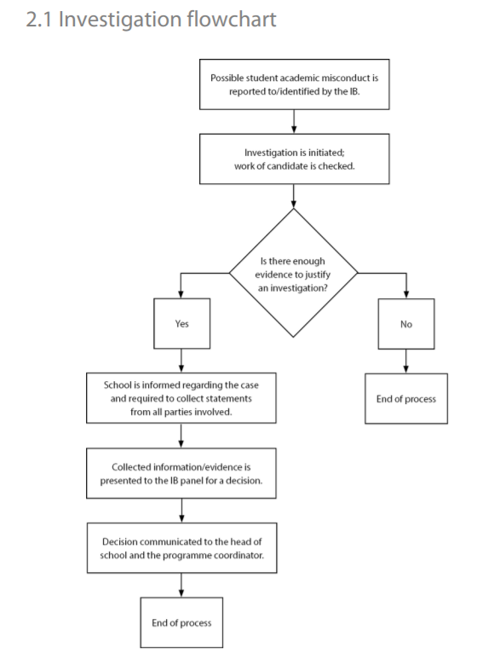

Written and Oral Coursework and Examinations:
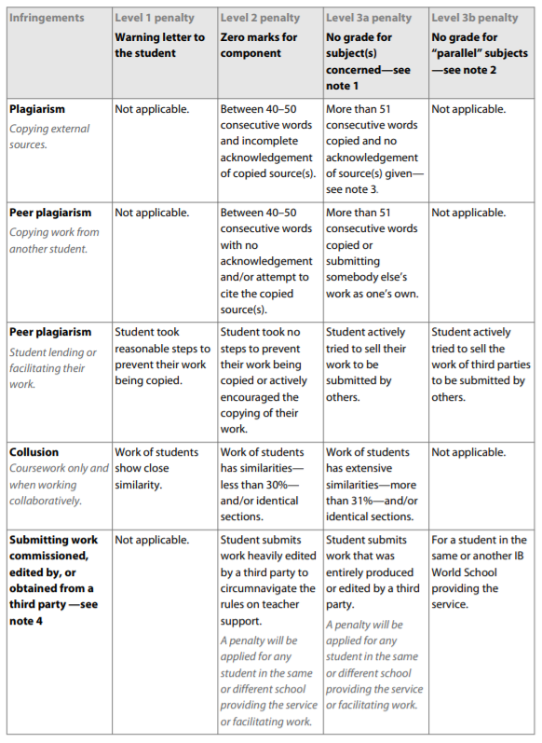
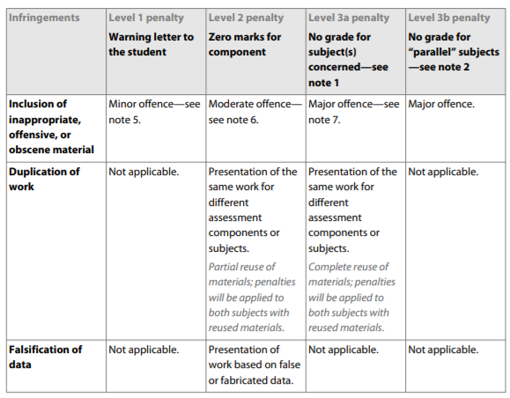
Conduct during Examination: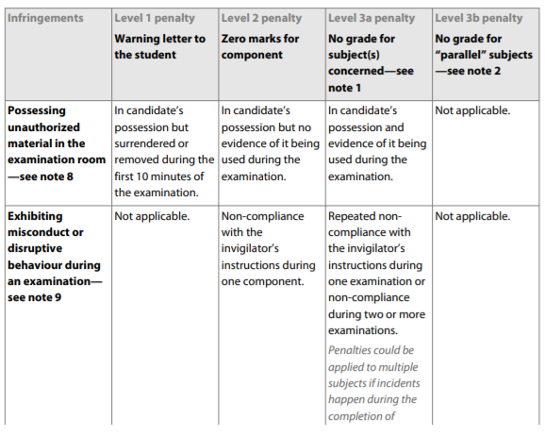
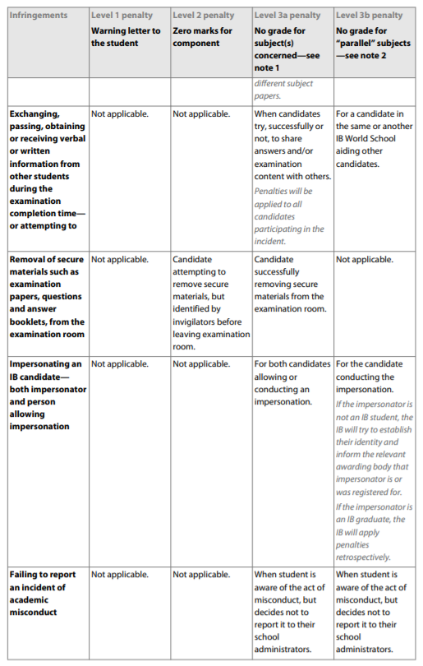
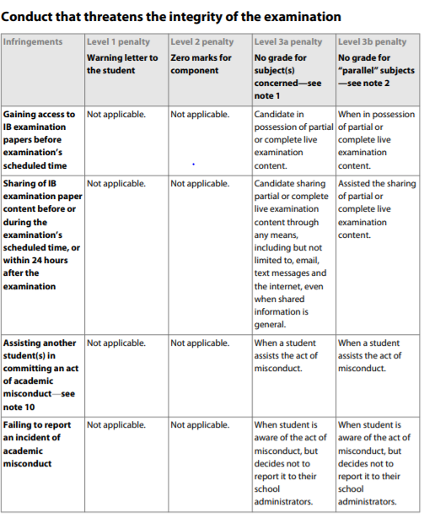

Works Cited
International Baccalaureate Organization. Academic Integrity Policy. Cardiff, UK, International Baccalaureate Organization, Oct. 2019, www.ibo.org/contentassets/76d2b6d4731f44ff800d0d06d371a892/academic-integrity-policy-english.pdf. Accessed 12 Nov. 2021.
‌

